**PROJECT DESIGN PHASE II**

**DATA FLOW DIAGRAM AND USER STORIES**

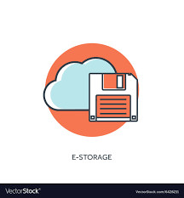**PERSONAL ASSISTANCE FOR SENIORS WHO ARE SELF-**  **RELIANT**

USER DATA STORING IN THE CLOUD

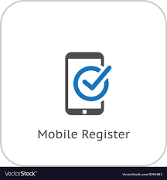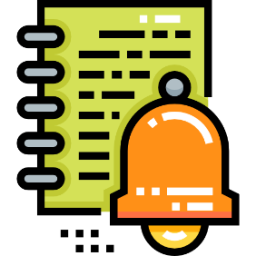

ACTIVATE THE REMINDER

REGISTRATION



LOGIN USING DETAILS

GET NOTIFICATION THROUGH THE PHONE



ENTER THE MEDICINE DATA

**USER STORIES**

|  |  |  |  |  |  |  |
| --- | --- | --- | --- | --- | --- | --- |
| **User Type** | **Functional Requirement** | **User**  **Story**  **Number** | **User Story/task** | **Acceptance Criteria** | **Priority** | **Release** |
| User | Register User | USN-1 | User can register themselves as a user | New user account is created | medium | sprint1 |
| User | Login | USN-2 | User login to the app | Going to the dashboard | medium | sprint2 |
| User | Add Medicine Details | USN-3 | User add his/her medicine details | Added medicine details successfully | high | sprint3 |
| User | Activate/  Deactivate  Reminder | USN-4 | User  activate/deactivate medicine reminder | Activated/ Deactivated successfully | high | sprint4 |
| User | Logout | USN-5 | User logout from the app | Logout the user | low | sprint4 |